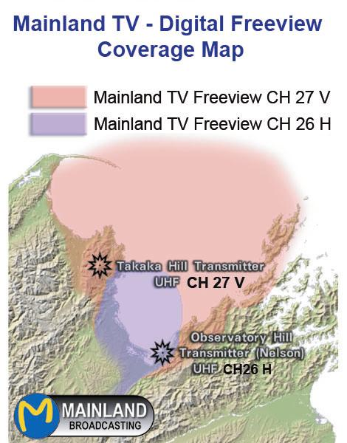

MAINLAND TV VIEWER RELEVANT FACTS

- As a result of our large local TV audience, NZ on Air funds our local Nelson region daily television news and this can also be heard daily at times on Radio 1, 88.3 FM & 107 FM.

- Mainland TV broadcasts 8 digital TV channels along side Freeview and SKY’S Igloo into about 92% of all homes in the Nelson region.

- Mainland TV has been broadcasting across the Nelson region since 1993 and is providing the most cost effective advertising opportunities for TV & Radio in our region.

Mainland Television Ltd – 133 Waimea Road Nelson. New Zealand – ph 546 6567- themanager@7-media.net
A free Technical TV Antenna report

This is a free TV antenna report from one of Mainland TV’s technicians or antenna contractors who has observed your UHF TV antenna and has made the following suggestions to help you obtain the best possible Digital TV pictures from Mainland TV, Freeview and Igloo terrestrial.

1/ Your UHF TV antenna is pointing in the wrong direction for all the TV channels and we suggest you point it –

A/ - towards the Takaka hill / Observatory hill. #

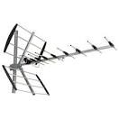
^ Reflector
B/ - remove the rear reflectors.

C/ - rotate the antenna 180 degrees

2/ Your UHF TV antenna is mounted in the wrong polarity for all the TV channels & we suggest you change it to –

A/ - Vertical polarity.

B/ - Horizontal polarity.

3/ Other comments or suggestions –
________________________________________________________________________________________________________________________________________________________________________________________________________________________________________________________________________________________________
See www.7-media.net for more details
RECEPTION OF MAINLAND TELEVISION: 8 Digital TV channels into 92% of all Homes

If you live in Stoke, Tahuna, Richmond, Wakefield Atawhai, The Glen, Brightwater, Motueka, Moutere, Tasman or Nelson City where you can see Observatory Hill or the Takaka Hill an outdoor UHF TV antenna should provide good quality reception. In door rabbit-ear type antennas do not always work with digital TV and should be avoided.

Our 8 UHF Digital TV channels are broadcasting from Observatory Hill so point one UHF antenna in that direction using Horizontal polarity. The same 8 Digital TV channels are also broadcasted from the Takaka Hill using vertical polarity. TVs have different instructions for different models so follow your TV manual and tune in these Digital UHF TV channels using autotune. Also remember to select the 16:9 manual setting, not auto on 16:9 TV’s.

If you live in remote areas, or areas over 15km from Observatory Hill or Takaka Hill, you will definitely require a good UHF antenna and in many cases a masthead amplifier may be needed to boost the signal. A booster is definitely recommended where 2 or more TVs are used as they divide up the signal coming down the cable. It doesn’t matter if the TV is connected or is turned on or not. Every time you add a second TV both get 50% of the signal. Four TV’s get 25% each of the signal and so on. It is also important to use low loss UHF type cable. Mainlands Takaka hill site is where the main road to Takaka passes the summit.

One UHF antenna should receive all the TV channels from Mainland TV, Freeview and Igloo. For those with SKY satellite a UHF antenna simply plugs into your digital TV for all Free to air & HDTV TV channels.

Please note: Always ask your SKY TV installer to make sure all your current UHF Mainland and Freeview digital TV channels are still nice and clear after any SKY installation as they must ensure Mainland and Freeview reception remains clear at no cost to you. Call SKY directly 0800 759 759. #

# NB By pointing your antenna at the Takaka hill you will get a better picture from Mainland and Freeview and Igloo will still work fine off the side of the antenna as they are much stronger. Tests show when antennas are pointed at the Takaka hill that all channels come in at a similar strength. You can remove your TV1,2 & 3 antennas as all Digital TV channels are only on UHF. Photos of UHF antennas are below.

TUNING IN TO MAINLAND TELEVISION:

We suggest you consult your TV manual, and tune into Mainland in the same way you would tune into Freeview. ALL Mainland TV channels operate 24 hours a day so you should always see a picture. SKY’S Igloo and Freeview set top boxes can also receive Mainland TV’s 8 TV channels.

If you live in Tahuna, Stoke, Atawhai or Motueka make sure your UHF antenna is pointing in the vertical polarity towards the Takaka Hill and not Mt Campbell. Freeview on Mt Campbell broadcasts more power so pointing your antenna toward Mainlands broadcast site on the Takaka hill where the main road goes over the Takaka hill will ensure all TV channels are of similar strength.

If you can see Observatory hill you will also get good reception. If you live in Nelson City central areas ( St Vincent St, the Wood, etc) you can point the UHF antenna horizontal towards Observatory hill and in some cases remove the reflector to enable Freeview and Igloo to come in from the rear.

Our website has details on TV antenna installers in our region plus many other tips for ensuring you receive all the Digital TV channels available and with a clear picture.
Horizontal Polarity for Observatory hill ( near 341 Princes Drive water tank, Nelson)
Vertical Polarity for Takaka hill site near SH6 road summit
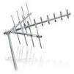

What TV Channels can I receive in the Nelson Region?

Mainland TV - 8 Digital TV channels & 2 Radio stations
       RADIO 1  
___________ Stream Mainland TV local news at www.7-media.net ______

Freeview Terrestrial - over 24 Digital TV channels including Mainland TV’s 8 Digital TV channels. #

________________________________________________
SKY’s Igloo – Over 35 Digital TV channels including Mainland TV’s 8 Digital TV channels and Freeview. #

_______________________________________________
SKY & Freeview Satellite viewers can still watch Mainland TV’s 8 Digital TV channels plus Freeview via a UHFantenna.#

If you have had a proffesional Antenna installer install your antenna and you can not receive the 8 Mainland TV channels and want to please let us know.

- Only in regions where terrestrial digital TV is available. Over 86% of NZ. Source Going Digital. NB Igloo, SKY & Freeview have no connection with Mainland TV and all logos are owned by the respective companies.

